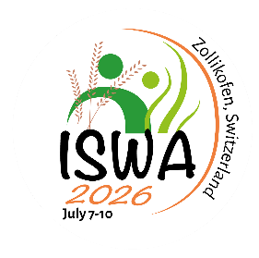
Application - Conference Sponsorship for Participants from Non-OECD Countries

The conference offers 10 sponsorships to support scholars from non-OECD countries. The sponsorship covers the full conference fee, including the conference dinner and excursion (travel and accommodation are not included).

Applications must be submitted by May 1, 2026.

Eligible applicants must:
- Be affiliated with an institution in a non-OECD country (verify OECD member list)
- Be the first author and presenting author of an accepted conference contribution

Selection will be based on:
- Academic relevance of participation
- Potential benefit for the applicant’s career and research
- Demonstrated financial need

Upload:
- Once the document is filled in, please upload it to ConfTool.

Personal Information
Full Name: | Click or tap here to enter text.
Affiliation (University, Institution): | Click or tap here to enter text.
Department: | Click or tap here to enter text.
Country of Residence: | Click or tap here to enter text.
Email Address: | Click or tap here to enter text.
Academic Position (e.g., MA student, PhD candidate, Postdoc, Faculty): | Click or tap here to enter text.

Conference Contribution
Title of your paper/presentation:
Confirmation:
☐ I confirm that I am the first author and presenting author of this contribution.
☐ I confirm that my contribution has been accepted for the conference.

Statement of Need
(Max. 300 words)
Why are you in need of sponsorship?
Address the following in your response:
- Financial constraints (e.g., lack of institutional funding, currency disparities).
- Barriers to participation (e.g., limited research budgets in your country).
- How this sponsorship would enable your attendance.

Click or tap here to enter text.

Impact Statement
(Max. 400 words)
Academic and Personal Benefits of Attendance
Address the following:
- Academic Impact:
  - How will presenting at this conference advance your research/career?
  - Potential collaborations or knowledge exchange opportunities.
- Personal/Professional Growth:
  - Skills or networks you aim to develop.
  - Long-term goals this conference aligns with.
- Broader Contribution:
  - How will your participation benefit your research team / institution?

Click or tap here to enter text.

Commitment and Acknowledgement
☐ I confirm that I will attend and present at the conference if selected. If selected, I will provide proof of participation by submitting a copy of my flight ticket by May 31, 2026.
☐ I understand that the sponsorship covers conference fees only (excluding travel and accommodation).
☐ I confirm that all information provided is accurate.

